Nhi Nguyen

QIIME2

1. Metadata file:

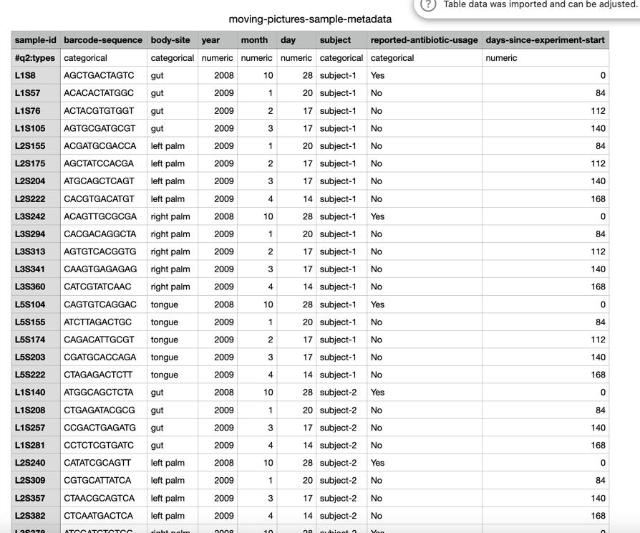

1. Barcode File:

Barcode.fastq

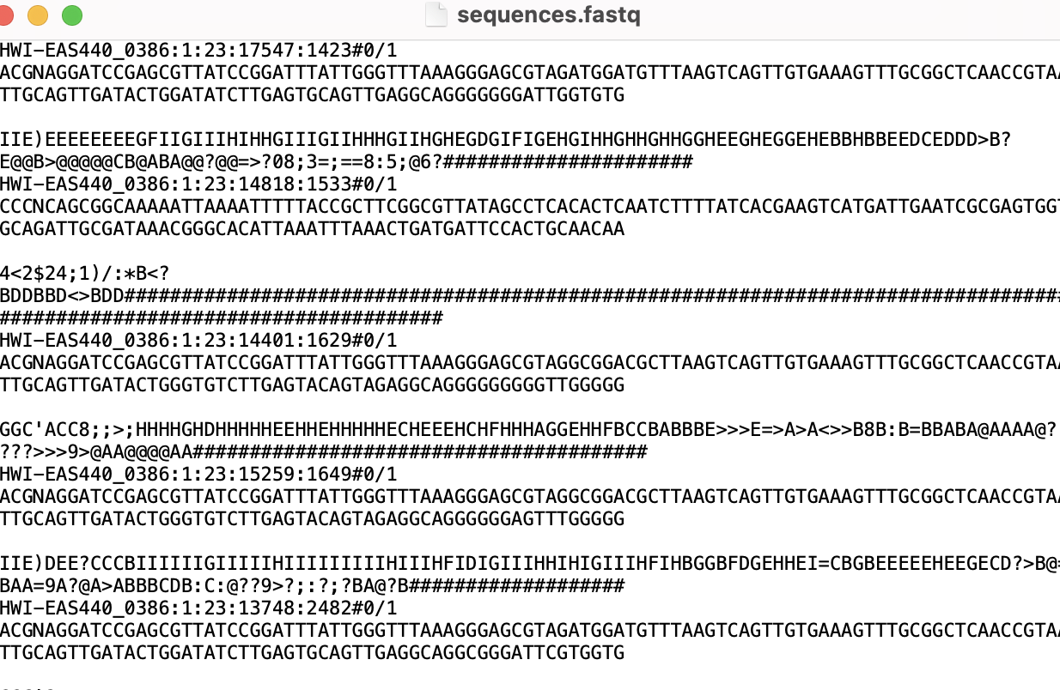

Sequence.fastq

1. A .qza file including citations and provenance

Req-seqs.qza

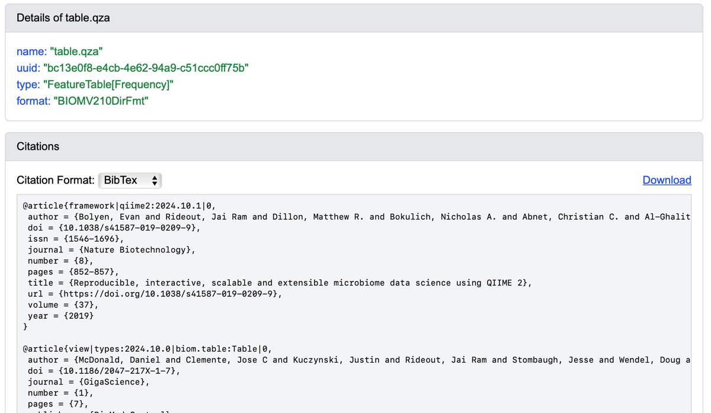

Table.qza

Table.qza (Prevenance)

Taxanomy.qza

Taxanomy.qza (Provenance)

1. The req-seq file

1. Demultiplexing

* demux.qza – demultiplexed sequences
* demux-details.qza – error correction info
* demux.qzv – visualization of sequence quality

Demux.qzv shows the quality of the sequence after separating by sample.

Helps you to decide where to trim before cleaning the data.

So in the figure, the quality drop after base 90 , so need to trim there before cleaning the data.

1. **Stat DADA2 Denoising:**

* table.qza – feature table
* rep-seqs.qza – representative sequences
* stats-dada2.qza – denoising stats
* stats-dada2.qzv – stats visualization

DADA2 is to helps to removes bad sequence, fix error , find clean sequence .

This is DADA2 denoising summary, so for each sample, it show how many reads were kept after filtering, denoising ,and removing chimeras. Most sample kept over 50% of reads, which consider good quality data.

**Feature table summary**

Table.qzv

**Representative sequence:**

Req-seqs.qzv

**Phylogeny:**

* aligned-rep-seqs.qza, masked-aligned-rep-seqs.qza
* unrooted-tree.qza, rooted-tree.qza

**Core diversity Analysis**:

* core-metrics-results/ :
* faith_pd_vector.qza, evenness_vector.qza,
* unweighted_unifrac_distance_matrix.qza,
* Emperor plots:
* unweighted_unifrac_emperor.qzv
* bray_curtis_emperor.qzv, etc.

Bray- curtis emperor days since experiment start

Bray curtis emperor

Jaccard emperor

unweighted_unifrac_emperor.qzv (beta diversity colored by site)

Weighted unifrac emperor

Beta-diversity plot colored by reported-antibiotic-usage

Alpha diversity boxplot (evenness-group-significance) (body site)

Alpha diversity boxplot (evenness-group-significance) (reported antibiotic usage)

Faith phylogenetic diversity (body site)

Reported antibiotic usage (faith pd group significance)

**Group significance:**

unweighted-unifrac-body-site-significance.qzv

Alpha Rarefaction:

alpha-rarefaction.qzv

**Taxanomy:**

**Taxa bar plots**

**Differential Abundance (gut only):**

**Results:**

**Beta-Diversity Plots:**

4 distance metrics were used : Bray Curtis, Jaccard, Unweighted Unifrac, Weighted unifrac

Each plot was rotated to show all 3 principal coordinate (PC1, PC2, PC3) and colored by body site.

For Bray Curtis, the plot show distinct clustering by location , means that each site has different ,microbial communities . With axis 1, explains the most variations (32.42%)

Bray curtis plot colored by antibiotic usage show that people who took anitibiotic have different microbial communities.

Weighted UniFrac has the highest value on axis 1, with 69%, means that it explains the most difference between sampled based on both species’ presence and abundance.

**Alpha-Diversity Plots:**

Evenness show how balanced the microbial community is

Faith’s Phylogenetic diversity show how many different types of microbes there are

By body site:

Gut and tongue have lower diversity and lower evenness. Gut has the lowest phylogenetic diversity and evenness, meaning it has fewer and more dominant microbes.

By antibiotic:

People who used antibiotics have lower diversity in both metrics

They have less rich and less balanced in microbial communities

From the bar plot, we can see that gut samples had more Bacteroides. Oral samples had more Streptococcus and Veilonella. Palm samples had more Corynebacterium and Propionibacterium.

These bar plots helps to explain the diversity result, that different body part support different microbes.